



Z Pedestal Base Automation Rev 0.00

It is very similar to the automation of the col in the master cooler. It is just less involved. It operates the same way.

Each of the col’s have a weldment page followed by a detail page of the component. We have renumbered the col’s so you do not have to renumber them for a 1Z or no sub col jobs. The pages will go blank. If not used on the job. So, if the sheet is missing the dwg views you can delete the page for the current job.

When you start a job. Start as usual.

1. In the top asm change the 3D sketch to the correct dims.
2. Then (control Q) and the col heights will update as usual.
3. Then pick the correct config to use, at this time. In the future we will automate this as well.
4. Next open the Col Base asm and the Col Base part. Make sure they are both on the Left Front Config for the design table to work properly.
5. Start with the Col Base part file first. Open the design table and make your changes.
6. Choose from the 3 drop downs in the table (shown below) and save the file.
7. Then go to the Col Base asm and open and close the table. It will now update.
8. Then save the file. That is all you need to do to update the col.
9. There is one more Design table int the Base Assembly.
10. Choose from the 2 drop downs in the table (shown below) and save the file.
11. Then save the file.

In the col part design table you will have 3 drop down questions to answer to properly update the col you will need for your current job.

. 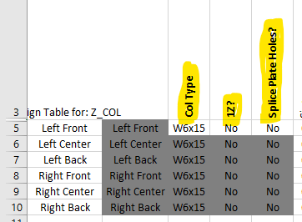

Col Type = W6 or W8 col size

1Z? = is it a 1Z Yes or No

Splice Place Holes = Does it use Splice Plates Yes or No

In the Col Base Asm table. This table will automatically update based on the col size. You will have the option to override the drop down options for the col base and join plates and flags for job specific parts. Otherwise these columns will be blank.

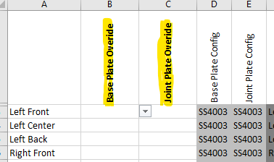

In the Base Assembly the design table you will have 2 drop down questions to answer to properly update the col you will need for your current job.

